Project Tracker

Iteration #4 Plan

11/10/2014 – 12/30/2014

# Revision History

|  |  |  |
| --- | --- | --- |
| **Author** | **Date** | **Description** |
| M. Rudner | 11/10/2014 | Initial Release |
|  |  |  |

# Objectives

The purpose of this iteration is to fix our home-page layout, added a search box, and search options.

# Use Cases

The following use cases are involved in this iteration:

* UC002: View a table of submitted project idea

# Task Schedule

|  |  |  |  |  |  |  |  |
| --- | --- | --- | --- | --- | --- | --- | --- |
| **Story ID** | Task | Effort | | Completion Date | | Owner | **Status** |
| **Est.** | **Actual** | **Est.** | **Actual** |
| S21 | Fixed home-page layout | 2 hours | 2 hours | 11/14 | 11/14 | Suenaga | Finished |
| S31 | Search box | 2 hours | 2 hours | 11/14 | 11/14 | Suenaga | Finished |
| S31 | Filter options | 2 hours | 2 hours | 11/14 | 11/14 | Suenaga | Finished |

# Task Pictures

## Fixed home-page layout:

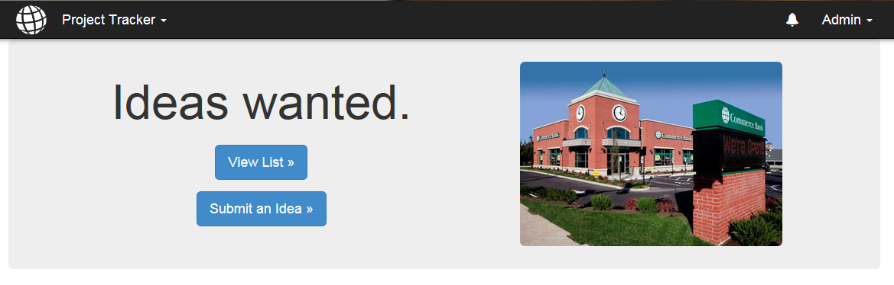

## Search box:

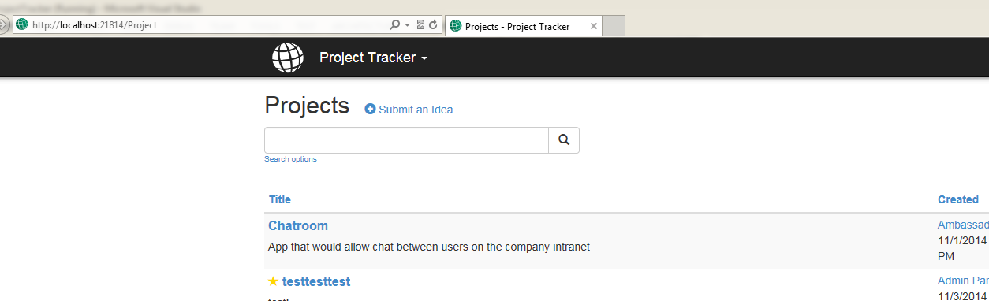

## Search options:

